|  |  |
| --- | --- |
| Mirror buildings  Assessment 4  Reflective Report, 2023 | Abstract  This will be my assessment 4’s final reflective report. The document consists of parts 1 and 2, as per the task requirements. There is a contents page at the beginning for effective navigation, and a final references page to list all the links that were used within the report.  Zhitan Wu  31266 – Introduction to Information Systems, University of Technology Sydney |

Table of Contents

1. Tutorial Reflection 2

**1.1 Business Chosen and Main Activities** 2

**1.2 Overall Benefit of IS** 2

**1.3 Tools In Week 4 Tutorial – Microsoft Text Analysis API** 2

**1.3.1 Brief Introduction** 2

**1.3.2 Sentiment Analysis** 3

**1.3.3 Entity Extraction, Bing Search and Language Model** 4

**1.3.4 Conclusion** 5

**1.4 Tools In Week 8 Tutorial – Google Trends** 5

**1.4.1 Brief Introduction** 5

**1.4.2 Lowercase Searching** 6

**1.4.3 Interest By Sub-Region** 6

**1.4.4 Related Topics and Queries** 7

**1.4.5 The ‘Compare’ Feature** 7

**1.4.6 Conclusion** 7

2. Making Informed Decisions Using Pivot Table 8

**2.1 Introduction** 8

**2.2 Report Filters** 8

**2.3 Row Labels** 9

**2.4 Column Labels** 10

**2.5 Values/Value Area** 11

**2.6 Conclusion** 12

3. References 13

# **1. Tutorial Reflection**

## **1.1 Business Chosen and Main Activities**

Ezy Math is the business that is chosen. It is a tutoring company that operates in several major cities in Australia, like Sydney, Melbourne, Perth, and Adelaide (Ezy Math Tutoring, 2020). Their tutoring is administered in-person or online. The company aims to provide quality private tutoring to students in Years 3 to 12. They advertise themselves as ‘a new type of maths tutoring company’, with tutors teaching students strategies for students to succeed in mathematics on their own, although tutoring for subjects like English and Science is also offered. (Ezy Math Tutoring, 2018)

## **1.2 Overall Benefit of IS**

In general, information systems offer numerous benefits to tutoring businesses, with the implementation allowing them to optimise their operations, enhance customer satisfaction and achieve sustainable growth. They provide valuable insights for decision making, enhance management organization, streamline internal communication, minimise administrative errors, improved customer interactions, and support future expansions. Effective communication between the tutors and the company is facilitated, enabling the identification of irregular sessions. Regular customer communication is prioritized, creating a sense that clients are valued. Information systems allow for the tracking of tutoring times and activities, while progress is being monitored and schedule adjustments are enabled. These systems can ultimately be scaled alongside business growth, while time is saved by automating tasks like invoice calculations and wage payments. (ChatGPT – Personal Communication (2023) : Teachworks blog, 2021)

## **1.3 Tools In Week 4 Tutorial – Microsoft Text Analysis API**

### **1.3.1 Brief Introduction**

The ‘Microsoft Text Analysis API’ tool can determine the sentiment expressed in user-inputted text by identifying key phrases that contribute to the tone, as seen in figure 4 (Microsoft AI, 2023).

If this tool was used for the business of Ezy Math Tutoring, an example may be any customer review left on Google Maps. The customer review can be placed into the API for it to generate a sentiment analysis in relation to the keywords mentioned.

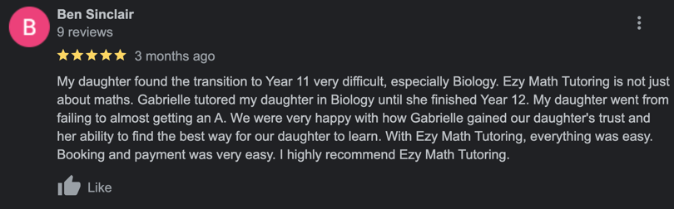

Figure 1: A Sample Review on Google Maps

Figure 3 depicts a random review on Google Maps that have been chosen for the Microsoft Text Analysis API to analyse. (Google Maps, 2023)

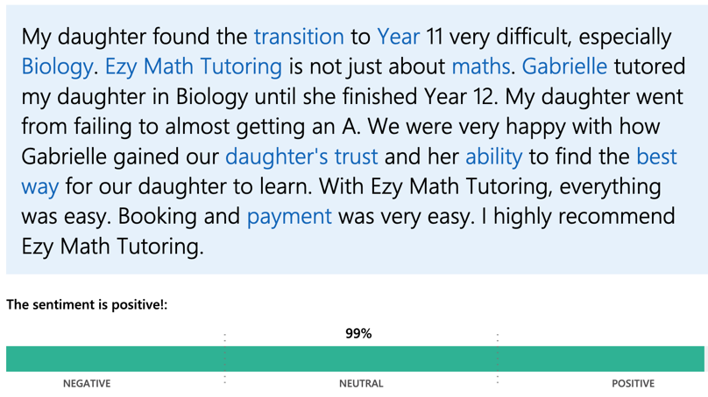

Figure 2: Analysis by the API

### **1.3.2 Sentiment Analysis**

Upon analysis, figure 4 is what arises. As pictured, the API highlights some keywords that are used to justify the sentiment rating. In a business context for Ezy Math, this can gauge whether customer reviews are positive or negative, allowing them to adopt a utilitarian approach in their services so that more people would be satisfied. (Microsoft AI, 2023)

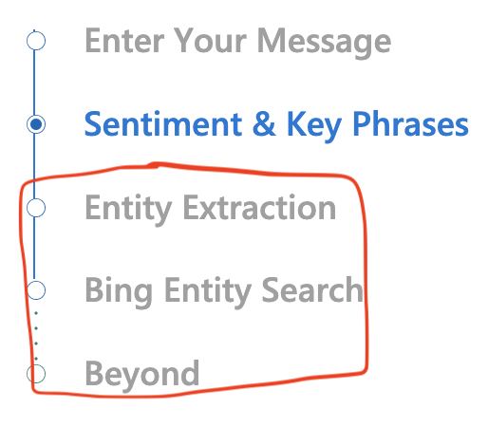

Figure 3: Some Features of the API

*Note: The red box contains the features that are of focus at the bottom*

### **1.3.3 Entity Extraction, Bing Search and Language Model**

The API incorporates entity extraction to identify customer preferences, both positive and negative. It integrates Bing search to help companies improve their services based on customer preferences. (Microsoft AI, 2023 | ChatGPT – Personal Communication)

Additionally, the API includes a powerful language model called Turing-NLG, which has seventeen billion parameters. It responds to prompts in a human-like manner, assisting companies while eliminating the typical biases associated with AI language models. (Microsoft Research, 2020 | ChatGPT – Personal Communication)

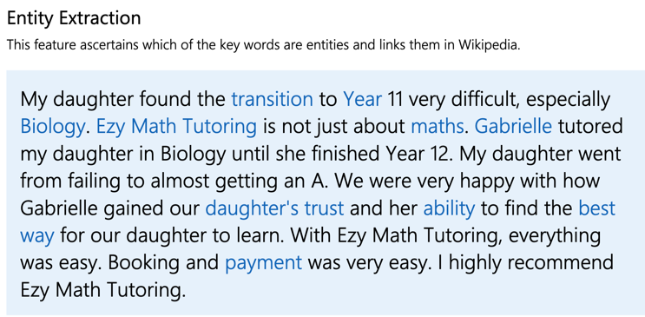

Figure 4: The ‘Entity Extraction’ Preview

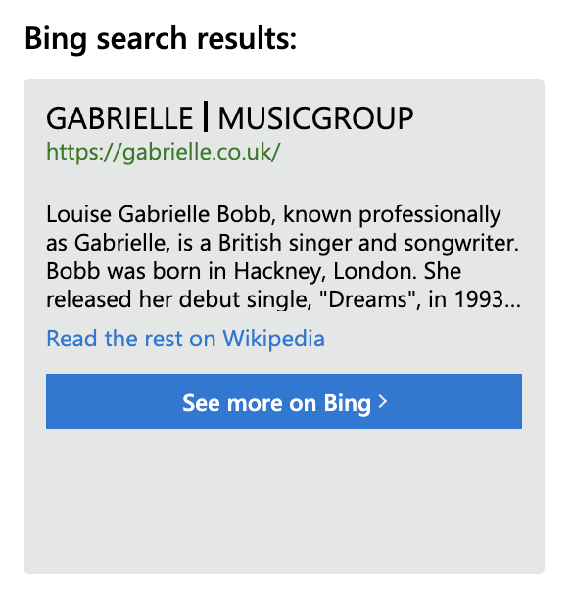

Figure 5: The ‘Bing’ Search Results

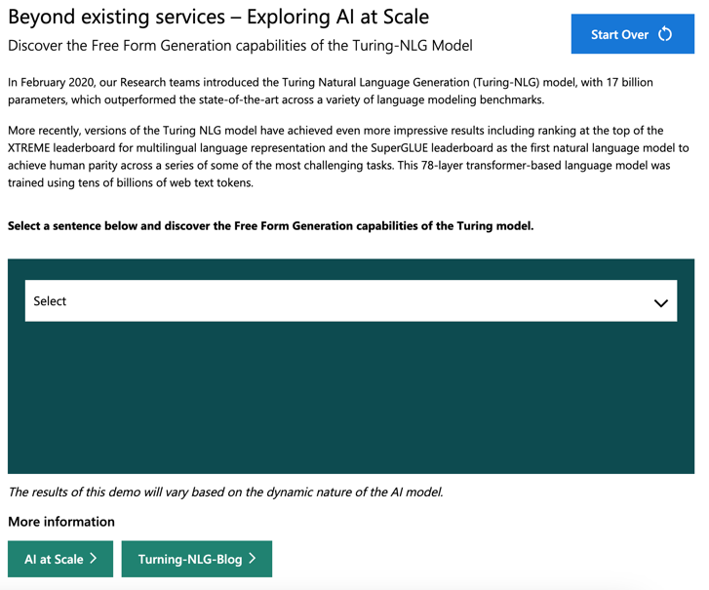

Figure 6: Turing NLG Model

### **1.3.4 Conclusion**

The Microsoft Text Analysis API can allow the tutoring business to visualise the overall customer perception of their services alongside the market and to make amendments where necessary. It has handy tools to enable effective communication within the company and to customers, increasing the company’s revenue and profits. (Microsoft AI, 2023)

## **1.4 Tools In Week 8 Tutorial – Google Trends**

### **1.4.1 Brief Introduction**

Google Trends analyses searched keywords based on a chosen topic. It filters data by various factors like year, region, and age. (Fabrikod, 2021)

It can assist tutoring businesses in market research while increasing customer awareness through important keywords and location-based service demand. Here is an example of what comes up if you just search ‘Ezy Math Tutoring’. (Google Trends | ChatGPT – Personal Communication)

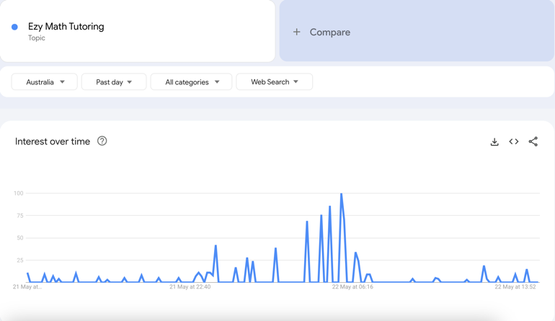

Figure 7: The ‘Interest Over Time’ For ‘Ezy Math Tutoring’ (Example)

### **1.4.2 Lowercase Searching**

However, lowercase searching for ‘Math Tutoring’ reveals more spikes, indicating greater historical popularity. Ezy Math can use this data when they analyse popular search characteristics and enhance them. They can target peak service demand and effectively advertise them in the process. (Google Trends, 2023)

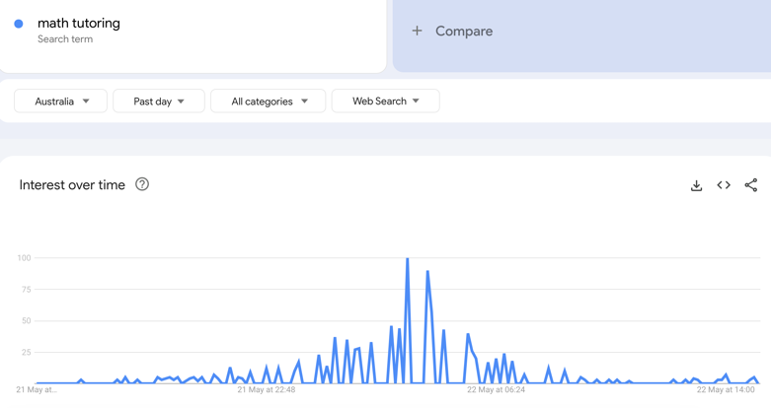

Figure 8: The ‘Interest Over Time’ For ‘math tutoring’ (Example)

### **1.4.3 Interest By Sub-Region**

The API provides sub-regional interest data for any search term across individual countries worldwide. By selecting 'Worldwide', it shows the overall interest across countries, influenced by word-of-mouth communication. Ezy Math can use this information to target specific demographics with customized advertisements, effectively promoting their tutoring service. (Google Trends, 2023 | ChatGPT – Personal Communication)

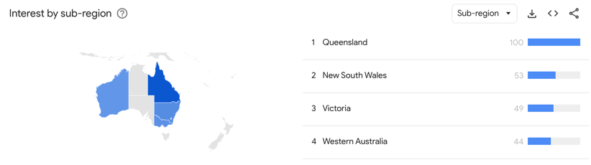

Figure 9: Interest by Sub-Region For ‘math tutoring’ In Australia (Example)

### **1.4.4 Related Topics and Queries**

The bottom of the page displays related topics and queries, serving as a resource for the business to identify potential competitors. By highlighting the unique benefits of their service, the business can differentiate itself from others in the market and increase its chances of survival. (Google Trends, 2023)

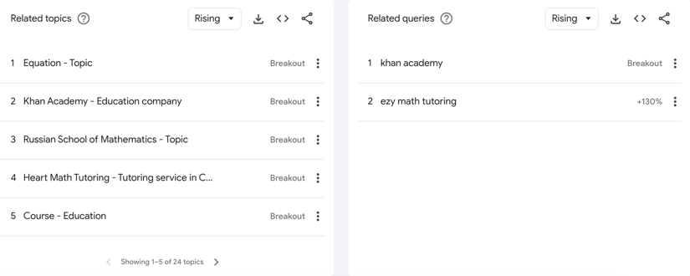

Figure 10: The ‘Related Topics’ and ‘Related Queries’ For ‘math tutoring’ Worldwide (Example)

### **1.4.5 The ‘Compare’ Feature**

The 'compare' feature in Google Trends allows businesses to gauge competition by comparing interest levels between them and other tutoring companies like Pre Uni-New College. This helps them develop unique methodologies to differentiate their brand and attract new customers to their service.

Here is an example of interest over time with a comparison. (Google Trends, 2023)

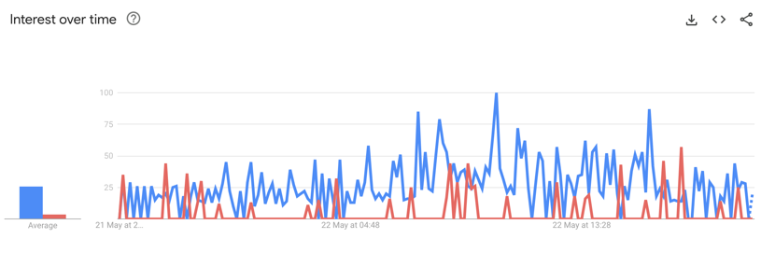

Figure 11: Comparison of The Interest Between ‘Pre-Uni New College’ and ‘math tutoring’

### **1.4.6 Conclusion**

Google Trends will allow Ezy Math to improve their marketing which can include online advertisements, while allowing them to perform a brand comparison with other companies. From this, they can complete routine brand assessments with analysis so that they can keep on surviving in the market. (Google Trends, 2023)

# 

# **2. Making Informed Decisions Using Pivot Table**

## **2.1 Introduction**

To present programming/software skills to the Executive committee, the pivot table's structure should adhere to statistical principles for effective data exploration. Certain data fields such as URL, low/high estimates, company founded, ratings, and job descriptions are irrelevant for understanding prevalent skills. The 'Country' field is also not crucial as it is consistently labelled as 'Australia'. (Australia Data Science Jobs – Pivot Table, 2023)

## **2.2 Report Filters**

Implementing 'filters' based on the ‘Company Industry’ variable will ensure that the R & D team of the tutoring business is able to filter the data based on different industries. They can then opt for specific sectors of interest to present to the executive committee. (Australia Data Science Jobs – Pivot Table, 2023)

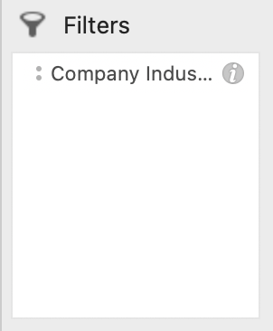

Figure 12: The Filters

Figure 13: The Output in The Pivot Table

## **2.3 Row Labels**

The ‘row labels’ will be assigned to the ‘company type’ variable that will categorise the companies based on their types (technology, finance, healthcare, etc.,). This will provide insight into how companies of various types can employ data science effectively, which will ultimately be valuable for the tutoring business’ R & D team to present to the Executive committee. (Australia Data Science Jobs – Pivot Table, 2023)

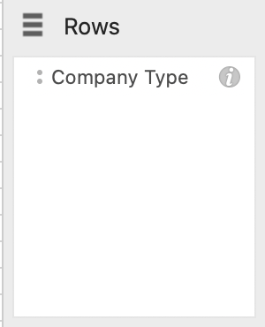

Figure 14: Row Labels

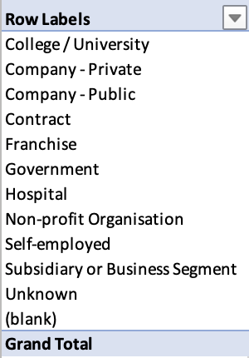

Figure 15: How the Row Labels Look Like in The Pivot Table

## **2.4 Column Labels**

The ‘column labels’ can be populated with the ‘Company Size’ value, which categorises the companies based on their size (small, medium, or large). This will prove to be beneficial for the tutoring business’ R & D team as it provides insights into how various company sizes can adopt data science which can possibly inform how they use it themselves. (Australia Data Science Jobs – Pivot Table, 2023)

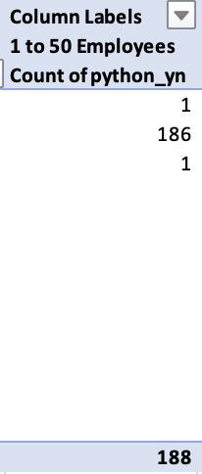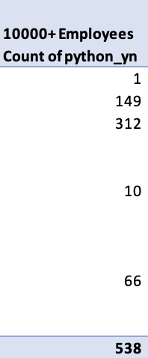

Figure 16: An Example Comparison With Relation To The Company Size And The Same Skill

## **2.5 Values/Value Area**

The 'values' can represent the frequency of programming/software skills in the companies. This can allow the R&D team of the tutoring business to analyse the frequency or count of each programming language or technology used by companies in different sectors, sizes, and types.

The R&D team of the tutoring business can use the 'count' function for the value area since the values in the dataset are binary. It can be used to quantify the number of individuals with specific skills. The Executive team can later easily analyse this quantitative measure within the companies and find out the ones that are the most common while locating trends/patterns. (Australia Data Science Jobs – Pivot Table, 2023)

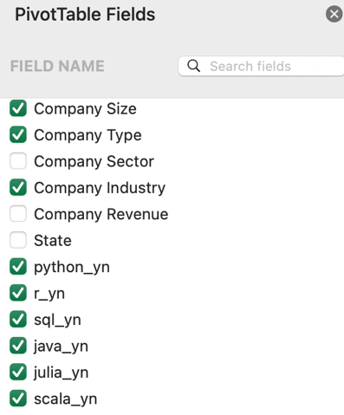

Figure 17: Some Fields Chosen for Pivot Table

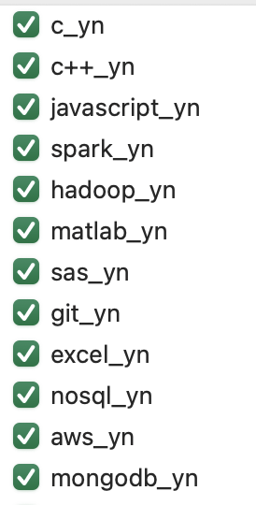

Figure 18: More Fields Chosen for Pivot Table

## **2.6 Conclusion**

Overall, the structure of the pivot table will allow for the analysis of data by the tutoring business to be meaningful. The statistical principles will ensure that insights are derived while making data-driven decisions in various company types, sizes, and sectors. They can also enhance the credibility and validity of the final pivot table, as data issues like missing values, outliers and inconsistencies are addressed. All these details will ensure that the R & D team of the tutoring business can effectively present their pivot table to the executive committee as intended. (Australia Data Science Jobs – Pivot Table, 2023)

**

Figure 19: A Section of The Pivot Table

# 

# **3. References**

ChatGPT. (2023). Personal Communication: Used it as a tool to edit my writing.

Ezy Math Tutoring. (2018). Expert Math Tutors Online or at your Home, Success in maths can be tough ... but it opens doors … Retrieved from

<https://www.ezymathtutoring.com.au/#:~:text=Ezy%20Math%20Tutoring%20is%20a,year%203%20to%20year%2012>

Ezy Math Tutoring. (2018). What we can offer. Retrieved from <https://www.ezymathtutoring.com.au/for-schools/how-we-solve-it/>

Ezy Math Tutoring. (2020). Tutor math with us and we’ll not only guarantee to find you the best tutor…We’ll make it risk-free! Retrieved from

<https://www.ezymathtutoring.com.au/lp/money-back/?campaignid=186617616&gad=1&gclid=CjwKCAjwgqejBhBAEiwAuWHioD1a6V62MulwntarJId1KdyLkLMCjM4rRsVsYHnA1DeYV6z3DKVahhoC6PAQAvD_BwE>

Google Maps. (2023). Ezy Math Tutoring Reviews. Retrieved from

https://www.google.com/maps/place/Ezy+Math+Tutoring/@-33.8912762,151.250367,17z/data=!3m1!5s0x6b12adf23db2c795:0x7a0f07442f39df1c!4m16!1m9!3m8!1s0x6b12ae1a7f269a7f:0x8f83876bd3b39b39!2sEzy+Math+Tutoring!8m2!3d-33.8912807!4d151.2529419!9m1!1b1!16s%2Fg%2F1tc_8ty3!3m5!1s0x6b12ae1a7f269a7f:0x8f83876bd3b39b39!8m2!3d-33.8912807!4d151.2529419!16s%2Fg%2F1tc_8ty3

Google Trends. (2023). Ezy Math Tutoring search trends. Retrieved May 23, 2023, from

<https://trends.google.com/trends/explore?q=Ezy%20Math%20Tutoring&date=now%201d&geo=AU&hl=en-GB>

Google Trends. (2023). Math tutoring search trends [Google Trends topic]. Retrieved May 23, 2023, from

<https://trends.google.com/trends/explore?date=now%201-d&q=math%20tutoring,%2Fg%2F11cs5frlp2&hl=en-GB>

Google Trends. (2023). Math tutoring search trends in Australia. Retrieved May 23, 2023, from

<https://trends.google.com/trends/explore?date=now%201-d&geo=AU&q=math%20tutoring&hl=en-GB>

Google Trends. (2023). Math tutoring search trends. Retrieved May 23, 2023, from <https://trends.google.com/trends/explore?date=now%201-d&q=math%20tutoring&hl=en-GB>

Google. (2023). Google Trends. Retrieved from <https://trends.google.com/trends/explore?q=Ezy%20Math%20Tutoring&date=now%201-d&geo=AU&hl=en-GB>

Microsoft AI Demos. (2023). Text Analytics. Retrieved May 23, 2023, from <https://aidemos.microsoft.com/text-analytics>

Microsoft Research. (2022, February 15). Turing NLG: A 1.7 billion parameter language model by Microsoft. Retrieved from

<https://www.microsoft.com/en-us/research/blog/turing-nlg-a-17-billion-parameter-language-model-by-microsoft/>

Teachworks. (2021, March 22). 7 Reasons to Use a Tutor Management System. Teachworks Blog. Retrieved from

<https://blog.teachworks.com/2021/03/7-reasons-to-use-a-tutor-management-system/>

W. Zhitan. (2023). Australia Data Science Jobs – Pivot Table. Retrieved from

[**Australia Data Science Jobs - Pivot Table.xlsx**](https://canvas.uts.edu.au/courses/26817/assignments/135894/submissions/166269?download=5042957)

Y. Zeynep. (n.d.). Benefits of Using Google Trends. Retrieved from <https://www.fabrikod.com/benefits-of-using-google-trends>